St Mary’s P.S. Altinure

Social Media Policy

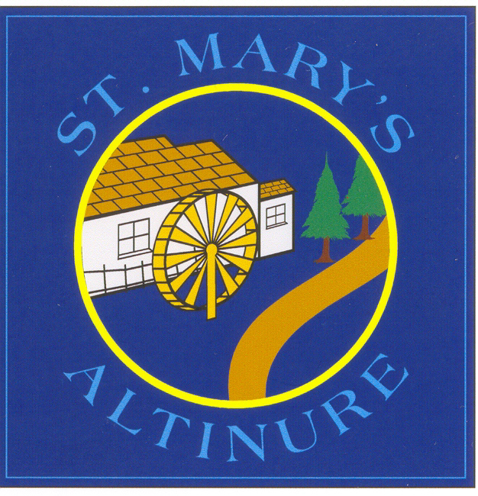

Updated by: Miss U Doyle 21/11/18

Adopted by Board of Governors 26th Nov 2018

Review Due: Nov 2020

- INTRODUCTION
Boards of Governors have a duty to safeguard and promote the welfare of pupils (Article 17 of the Education and Libraries (Northern Ireland)
Order 2003). It is also the duty of the Board of Governors to determine the measures to be taken at a school to protect pupils from abuse (Article 18 of the Education and Libraries (Northern Ireland) Order 2003 refers).
In the exercise of those duties, Boards of Governors must ensure that their schools have a policy on the safe, healthy, acceptable and effective use of any social media linked to the school. They must also actively promote safe and acceptable working practices for all staff and pupils: these will serve to reassure parents and guardians.

This Social Media policy contains policies in relation to use of the internet, use of mobile digital devices and use of digital/photographic images of children. It is largely based on DENI Circular 2016/27 “Online Safety”. It should also be read in conjunction with the School’s Child Protection, E Safety and use of Digital Devices, Positive Behaviour, Data Protection, Special Educational Needs and Anti-Bullying policies.

2. SOCIAL MEDIA DEFINITION

Social media technologies take on many different forms including magazines, Internet forums, weblogs, microblogging (Twitter), social networks (Facebook, Snap Chat, Instagram, Myspace, etc.), podcasts, photographs or pictures, video and virtual game worlds.

Over recent years, social media tools have become an integral feature of modern life, providing opportunities for organisations and individuals to engage and communicate. A key feature of many social media tools is their unparalleled ability to broadcast and receive information quickly and link to a whole network of people in a matter of seconds. It is also the case that material broadcast via Facebook and Twitter can persist in the digital world almost indefinitely, often reaching a wider audience than the author had originally intended.

Involvement in social networking sites such as Facebook & Twitter are an essential part of our lives, and bring many benefits. However, posting material, images or comments on sites can have an element of risk in relation to protecting children, and can also have a negative effect on an organisation’s reputation or image.

As a public body responsible for the care and education of children, St. Mary’s Altinure Primary School is committed to the responsible and appropriate use of social media.
This policy has been written to set out the key principles and code of conduct that we expect of all members of the St. Mary’s Altinure Primary School community, including staff, governors and families with respect to their use of social networking sites.

This document sets out the policy and practices for the safe and effective use of Social Media connected with St Mary’s PS Altinure. The policy has been drawn up by the staff of the school under the leadership of the ICT Co-ordinator Miss U Doyle and Principal Mrs Mary Redmond. It has been approved by the Board of Governors and is available to all parents via the school website and as a hard copy, if requested.

The policy and its implementation will be reviewed regularly.

SAFEGUARDING
Safeguarding children is a key responsibility of the entire St. Mary’s PS community – staff, pupils, parents/guardians and governors. It is essential that everyone involved with our school considers this and acts responsibly if they are using social networking sites out of school. Anyone working in the school either as a paid employee or volunteer must not communicate with children via social networking or arrange any social or informal meeting outside of school.

Parents are responsible for ensuring children engage with age appropriate social media. They should look online for minimum registration ages for sites such as Facebook, as many are not deemed suitable for Primary age children.

Everyone at St. Mary’s P.S. has a responsibility to ensure that they protect the reputation of the school, and to treat colleagues and members of the school with professionalism and respect. It is important to protect everyone at St. Mary’s Primary School from allegations and misinterpretations which can arise from the use of social networking sites.

POLICY AIMS:

This guidance is not intended to supress discussion or interfere with private use of social media tools. Along with our right to freedom of speech, we also have a responsibility to ensure that others are not harmed by our written words. This policy aims to:

- Clarify expectations about the use of social media tools by pupils, parents, carers, visitors and staff as it relates to St. Mary’s Primary School.

- Outline the procedures the school will take if it considers social media content to be offensive, inappropriate, inaccurate or otherwise unacceptable.

- Protect the reputation of St. Mary’s P.S. and ensure that social media use supports its educational, spiritual and pastoral ethos.

- Support the use of existing school policies and procedures to resolve issues of concern.

- Ensure that GDPR regulations are followed.

SOCIAL MEDIA CODE OF CONDUCT FOR ST MARY’S PS ALTINURE SCHOOL COMMUNITY

St. Mary’s Primary School has a safeguarding duty to all of its pupils and staff and will take appropriate action if it considers social media contents to compromise this. This can include
a) the possible or actual identification of a child or member of staff through an online discussion; and
b) the use of photos or videos without the consent of all involved.

Parents/carers and other family members are permitted to take photographs and videos of their child/children during school events such as assemblies, Christmas Shows, the Sacraments and other celebratory events. However, if children other than their own are included in these images/videos, they must first obtain consent from parents/carers of all children involved before posting on social networks or sending to others via email.

St. Mary’s Primary School has policies and procedures for a wide range of issues including bullying, attendance, SEN and complaints. As such, social media tools are not an appropriate vehicle for evolving such matters. Schools will not engage with parents/carers via this route but will direct parents/carers to the appropriate procedure.

Slanderous, offensive or derogatory comments regarding the school or any of the pupils/staff/parents at the school are not to be made on social media sites. When factually incorrect information is posted about the school via social media, the author(s) will be contacted by the school for its removal/correction.

The following are not considered acceptable at St. Mary’s Primary School:

The use of the school’s name, logo, or any other published material without prior permission from the Principal. This applies to any published material including the internet or written documentation.

The posting of any communication or images which link the school to any form of inappropriate conduct or which may damage the reputation of the school. This includes defamatory comments.

The disclosure of confidential or business-sensitive information or the disclosure of information or images that could compromise the security of the school.

The posting of any images or videos of employees, children, governors or anyone directly connected with the school whilst engaged in school activities without the prior permission of the Principal and/or parents/carers of the children involved.

STAFF SOCIAL MEDIA CODE OF CONDUCT

Staff should only access social media sites in their own time

Staff must not add parent/carers of school pupils as friends on Social networking sites such as Facebook, unless there is a pre-existing connection.

Staff should not comment on any posts made by others relating to the school, unless in a positive manner on the school ‘Friends of St Mary’s PS’ Facebook page.

Staff should not accept friend requests from current or past pupils of St Mary’s PS, unless in special circumstances such as being related or the past pupil becoming a working colleague.

Staff should behave respectfully and should not engage in topics that may be
considered objectionable or inflammatory such as politics or religion.

PROCEDURES IF SOCIAL MEDIA CODE OF CONDUCT IS NOT ADHERED TO:

It is hoped that, in the interest, safety and well-being of all in the St Mary’s PS Community, the Social Media Code of Conduct is followed. However, in the event of any breach of the Code of Conduct, appropriate procedures will be applied:

- If an image or video of a child is posted on a social network without the parent/carers consent, this a breach of our Code of Conduct. If this is brought to our attention, the poster will be contacted and asked to remove it immediately.

- In the event that any pupil or parent/carer of a child being educated at St. Mary’s P.S. is found to be posting libellous or defamatory comments on Facebook or other social network sites, they will be reported to the appropriate 'report abuse' section of the network site. All social network sites have clear rules about the content which can be posted on the site and they provide robust mechanisms to report contact or activity which breaches this.

- In serious cases or for repeat offences, the school will also consider its legal options to deal with any such misuse of social networking and other sites.

- Our school community takes the issue of cyber bullying very seriously. Any use by a member of the school community to publicly humiliate, embarrass or otherwise distress another by inappropriate social network entry will be dealt with in accordance with our policies such as Anti-Bullying and/or Positive Discipline.

- Where it is found that there has been a breach of this policy by a staff member, an investigation will ensue, and this may result in action being taken under the Disciplinary Procedure. A breach of this policy will be considered to be a serious disciplinary offence which is also contrary to the school’s ethos and principles.

Signature of Chairperson of BOG: _________________________________

Signature of Principal: _________________________________

Date ___________

